Conceptual Art: art in which the idea presented by the artist is considered more important than the finished product

Conceptual photography: photography that illustrates an idea

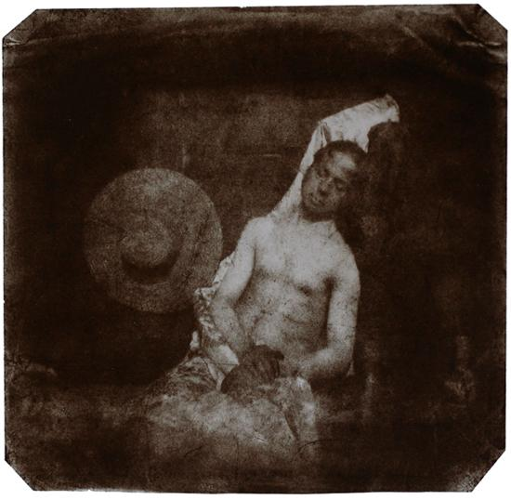 Hippolyte Bayard- He took this because he felt he had been treated with injustice and this is how he reacted.

Hamze Dashtrazmi- He took this because he was trying to show how he doesn’t like false advertising.

Adrian Sommeling- is showing how kids are affected by their parents fighting

